CAP 492
Artificial Intelligence

Tutorial # 3

Q1:
1. Describe a heuristic estimating function that will make A* search behave exactly like uniform-cost search for a given cost function.

2. Describe a heuristic estimating function that will make greedy search behave like breadth-first search.

Q2:
Give a proof for the following consequence of heuristic consistency:
If h(n) is consistent, then the values of f(n) along any path are nondecreasing.

Q3: Trace BFS, DFS, IDS and UCS using the graph given below where : A represents the starting node, G the goal node and numbers on arcs represent step costs.

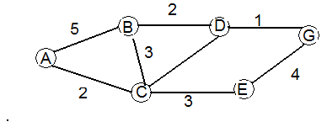
Q4: Prove each of the following statements:
- Breadth first search is a special case of uniform cost search.
- Breadth first search, depth first search and uniform cost search are special cases of best first search.
- uniform cost search is a special case of A*.

Q5: In the following figure, it is desired to reach a goal point (G) starting from a start node (a).
The indicates a state. Only 7 states are
a
b
c
d
G
e
f
shown.
1. Complete the states required to
make the search (Hint: 4 states).
2. Perform the search using depth
first, then using breadth first.
Which of them has better
performance?

- Can you think of a more suitable search
technique for this problem? Apply it to get
the solution and state why this technique is
better?

(P.S. You can assume any data that may help you in the chosen search technique).

